HOME BREW D-STAR

by Satoshi 7M3TJZ/AD6GZ

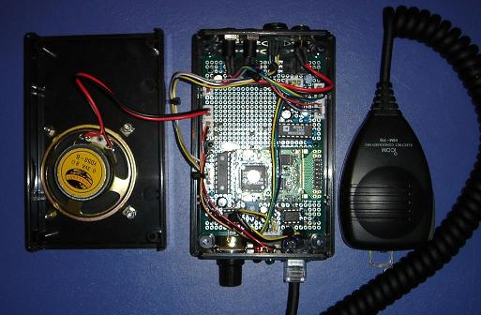

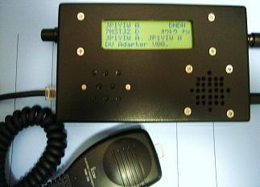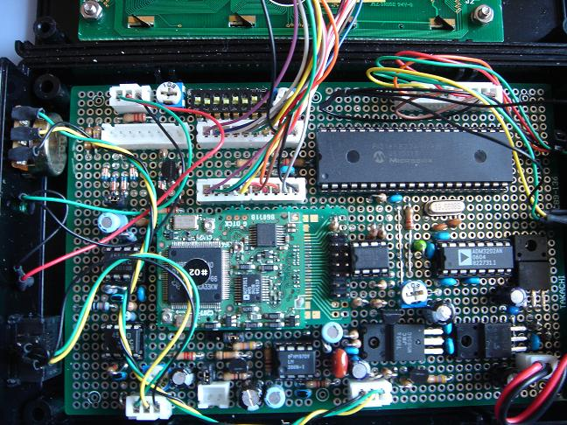

Satoshi Yasuda 7M3TJZ/AD6GZ Homebrew DV Adapter using UT-118

This project is an on going work in progress last update Nov 19, 2007.

